**Build/Start Nix Shell**

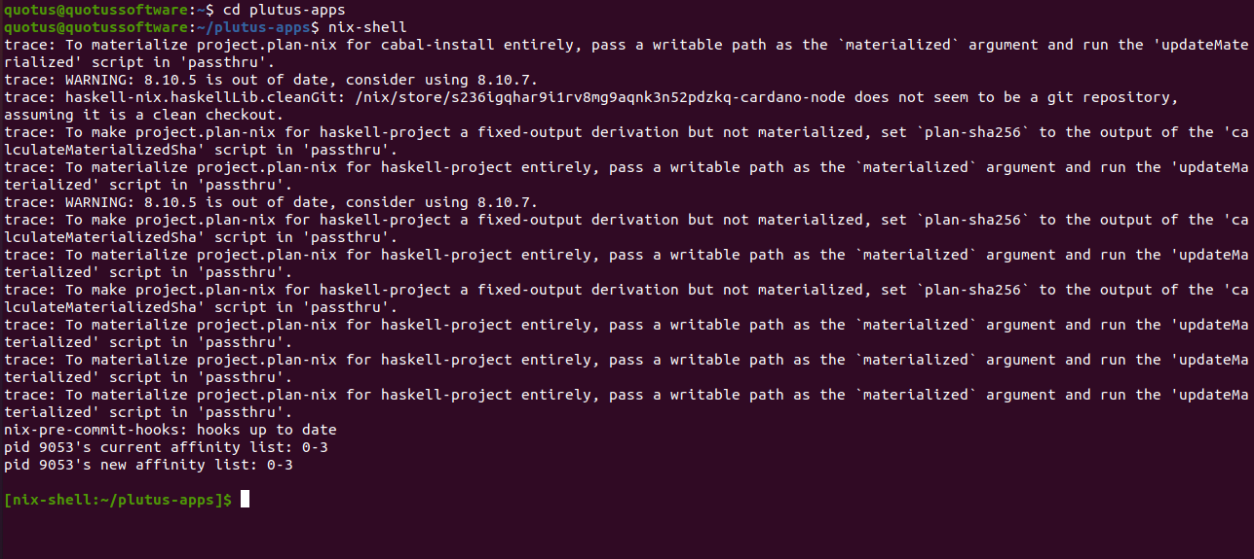

**Go To Plutus-pioneer-program**

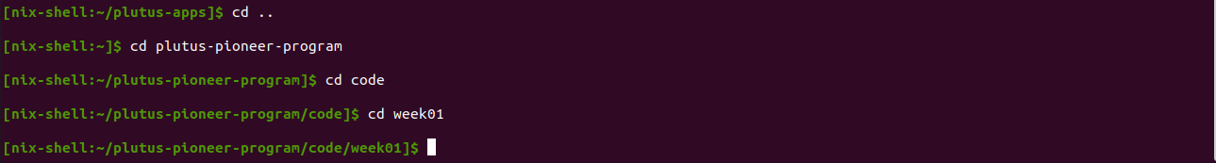

**Cabal Build & Repl**

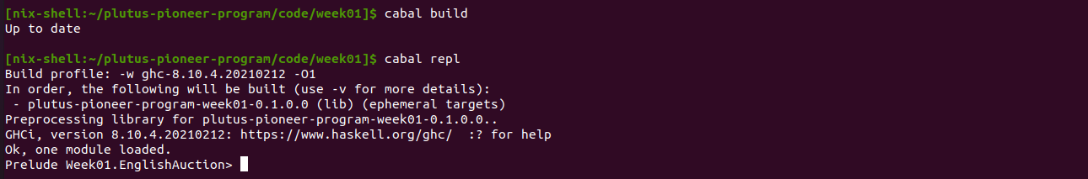

**Or Run in the VSCode**

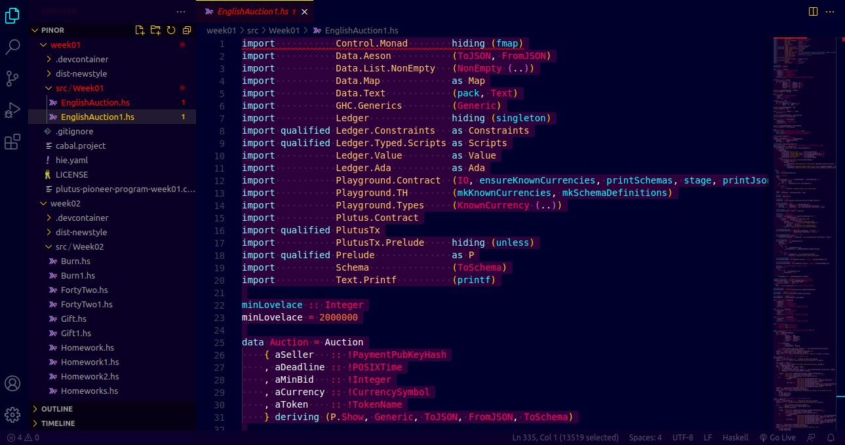

**Open new Terminal - Start Playground Server**



**Playground Client**

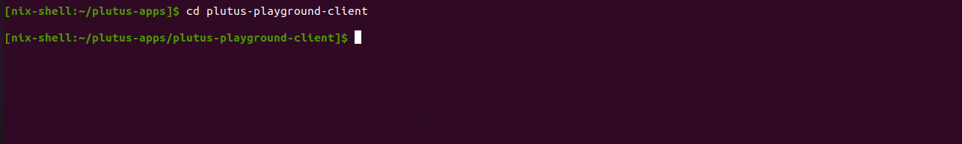

**Start Plutus Playground Server**

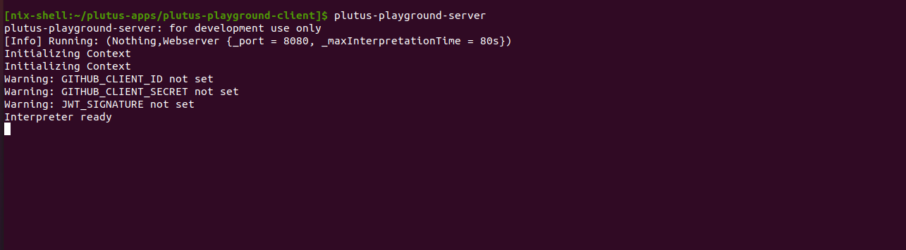

**Open another new terminal – for npm**



**Again enter into the plutus playground client**

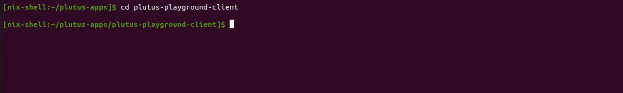

**Run the npm start**

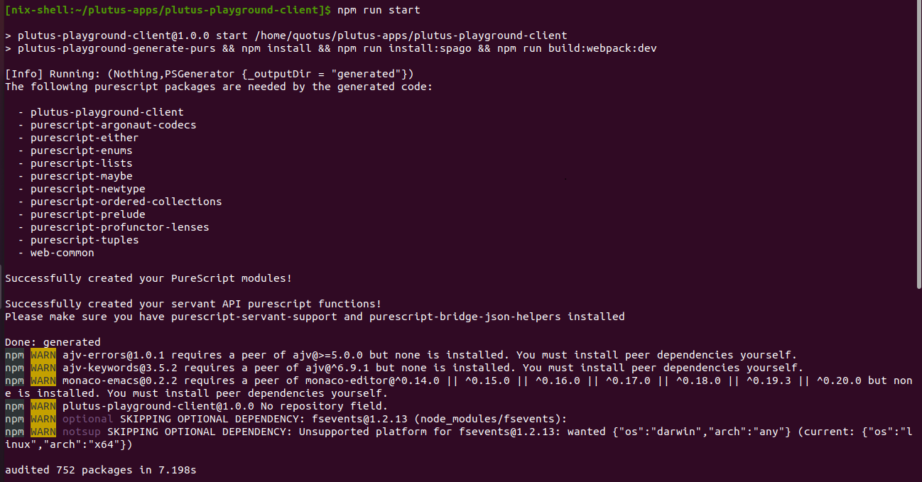

**Start Playground client at the localhost**

